DAA Assignment 2 – CO2
Q1 – Sorting Under Different Data Conditions
Problem Context: E-Commerce Order Processing
1. Aim
To implement and compare Selection Sort, Bubble Sort and Insertion Sort using different input arrangements by measuring the number of comparisons, swaps and movements.
2. Concept
Sorting algorithms arrange elements in ascending or descending order.
The three algorithms work differently:
- Selection Sort: Finds the smallest element and places it in its correct position.
- Bubble Sort: Compares adjacent elements and swaps them if they are in the wrong order.
- Insertion Sort: Takes one element at a time and inserts it into its correct position.
3. Prediction Before Implementation
Input condition | Selection Sort | Bubble Sort | Insertion Sort
Random data | Moderate | More operations | Moderate
Nearly sorted | Same comparisons | Very few swaps | Very efficient
Already sorted | Same comparisons | Very efficient with early stopping | Very efficient
Reverse sorted | Same comparisons | Maximum swaps | Maximum shifts
Algorithmic reason:
- Selection Sort always searches the remaining unsorted elements to find the minimum.
- Bubble Sort performs fewer operations when the data is already sorted, provided early stopping is used.
- Insertion Sort performs very well when the input is already or nearly sorted because fewer shifts are required.
4. Design of Test Datasets
We use three deliberately designed datasets.
Dataset | Input values | Purpose
Dataset 1 | [9, 4, 7, 2, 8, 1] | Random arrangement
Dataset 2 | [1, 2, 4, 3, 5, 6] | Nearly sorted
Dataset 3 | [6, 5, 4, 3, 2, 1] | Reverse sorted
5. Python Implementation
# Q1: Comparison of Sorting Algorithms
import copy
# Selection Sort
def selection_sort(arr):
arr = arr.copy()
comparisons = 0
swaps = 0
n = len(arr)
for i in range(n - 1):
min_index = i
for j in range(i + 1, n):
comparisons += 1
if arr[j] < arr[min_index]:
min_index = j
if min_index != i:
arr[i], arr[min_index] = arr[min_index], arr[i]
swaps += 1
return arr, comparisons, swaps
# Bubble Sort with early stopping
def bubble_sort(arr):
arr = arr.copy()
comparisons = 0
swaps = 0
n = len(arr)
for i in range(n - 1):
swapped = False
for j in range(n - i - 1):
comparisons += 1
if arr[j] > arr[j + 1]:
arr[j], arr[j + 1] = arr[j + 1], arr[j]
swaps += 1
swapped = True
if not swapped:
break
return arr, comparisons, swaps
# Insertion Sort
def insertion_sort(arr):
arr = arr.copy()
comparisons = 0
movements = 0
for i in range(1, len(arr)):
key = arr[i]
j = i - 1
while j >= 0:
comparisons += 1
if arr[j] > key:
arr[j + 1] = arr[j]
movements += 1
j -= 1
else:
break
arr[j + 1] = key
return arr, comparisons, movements
# Test datasets
datasets = {
"Random Data": [9, 4, 7, 2, 8, 1],
"Nearly Sorted": [1, 2, 4, 3, 5, 6],
"Reverse Sorted": [6, 5, 4, 3, 2, 1]
}
# Execute experiments
for name, data in datasets.items():
print("\nDataset:", name)
print("Original:", data)
result1 = selection_sort(data)
result2 = bubble_sort(data)
result3 = insertion_sort(data)
print("\nSelection Sort")
print("Sorted:", result1[0])
print("Comparisons:", result1[1])
print("Swaps:", result1[2])
print("\nBubble Sort")
print("Sorted:", result2[0])
print("Comparisons:", result2[1])
print("Swaps:", result2[2])
print("\nInsertion Sort")
print("Sorted:", result3[0])
print("Comparisons:", result3[1])
print("Movements (shifts):", result3[2])
print("-" * 40)
6. Expected Experimental Output
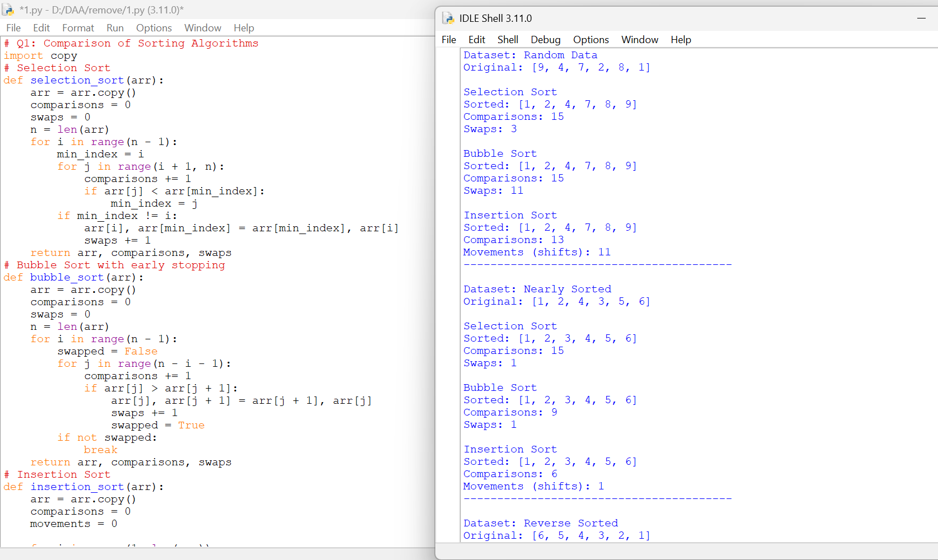
7. Comparison of Prediction and Observation
- In random data, all three algorithms successfully sorted the elements.
- In nearly sorted data, Insertion Sort required only 6 comparisons and 1 shift.
- Bubble Sort also performed well because early stopping reduced unnecessary comparisons.
- Selection Sort performed 15 comparisons for all three datasets because its search pattern does not depend on the initial ordering.
- In reverse sorted data, Bubble Sort and Insertion Sort required more swaps and shifts.
The experimental results support the initial prediction that input arrangement affects algorithm performance.
8. Time Complexity Analysis
Algorithm | Best Case | Average Case | Worst Case
Selection Sort | O(n²) | O(n²) | O(n²)
Bubble Sort (optimized) | O(n) | O(n²) | O(n²)
Insertion Sort | O(n) | O(n²) | O(n²)
9. Design Decision
The fulfilment centre reports that approximately 95% of existing orders are already in the correct priority order.
I recommend Insertion Sort for this situation.
Reasons:
- It performs efficiently on nearly sorted data.
- It requires fewer comparisons when only a few elements are misplaced.
- It does not require additional memory for another array.
- It is suitable for inserting small batches of new orders into an already sorted list.
Selection Sort is less suitable because it always performs approximately the same number of comparisons, regardless of the input arrangement.
10. Conclusion
Thus, Selection Sort, Bubble Sort and Insertion Sort were implemented and tested using random, nearly sorted and reverse sorted datasets. The experiment shows that no single sorting algorithm is always the best for every input condition. Since the fulfilment centre receives approximately 95% already sorted orders, Insertion Sort is the most appropriate choice.

Q2 – When Is Sequential Search an Appropriate Engineering Choice?
Problem Context: Aircraft Maintenance Tool Tracking
1. Aim
To implement Sequential Search and investigate its performance for successful and unsuccessful searches using different list sizes by counting the number of comparisons.
2. Concept
Sequential Search is a searching technique in which each element is checked one by one until the required element is found or the list ends.
In an aircraft maintenance facility, Sequential Search is used to identify which technician currently has a particular tool.
For example, searching for Tool ID T-184 in a list of issued tools.
3. Algorithm
- Start with the first element of the list.
- Compare the current element with the target element.
- If both match, return its position.
- Otherwise, move to the next element.
- Repeat until the element is found or the list ends.
- If no match is found, return -1.
4. Prediction Before Implementation
Search condition | Expected comparisons
Element at first position | 1
Element at middle position | Approximately n/2
Element at last position | n
Unsuccessful search | n
Reason: Sequential Search checks elements in order. Therefore, the number of comparisons depends on the position of the target element.
5. Python Implementation
def sequential_search(arr, target):
comparisons = 0
for i in range(len(arr)):
comparisons += 1
if arr[i] == target:
return i, comparisons
return -1, comparisons
# Experiment with different list sizes
sizes = [10, 50, 100]
for n in sizes
tools = ["T-" + str(i) for i in range(1, n + 1)]
print("\nList Size:", n)
# Successful search at first position
position, count = sequential_search(tools, "T-1")
print("First Position:", count)
# Successful search at middle position
middle = "T-" + str(n // 2)
position, count = sequential_search(tools, middle)
print("Middle Position:", count)
# Successful search at last position
last = "T-" + str(n)
position, count = sequential_search(tools, last)
print("Last Position:", count)
position, count = sequential_search(tools, "T-999")
print("Unsuccessful Search:", count)
6. Experimental Output
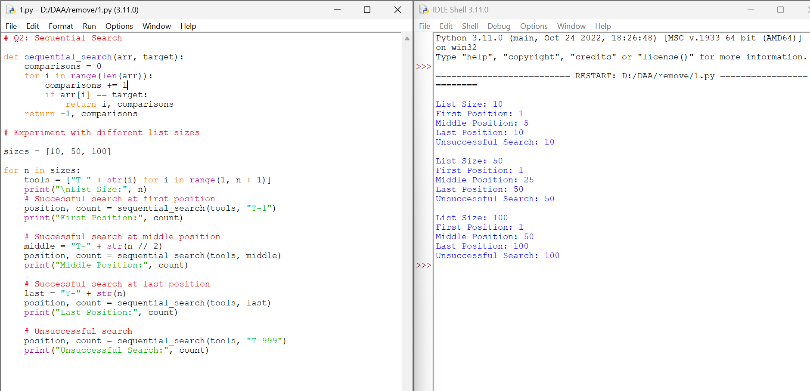
7. Experimental Analysis
The experimental results show:
- Searching for an element at the first position requires only one comparison.
- Searching for an element in the middle requires approximately half the list size in comparisons.
- Searching for an element at the last position requires checking all elements.
- An unsuccessful search also requires checking every element.
As the list size increases, the number of comparisons also increases.
8. Time Complexity
Case | Time Complexity
Best Case | O(1)
Average Case | O(n)
Worst Case | O(n)
Space Complexity: O(1).
9. Engineering Decision
Sequential Search is a reasonable choice when:
- The dataset is small.
- Records are frequently added and removed.
- The list is unsorted.
- Search requests are relatively infrequent.
- Additional memory for indexing is not desirable.
It becomes less suitable when the dataset is very large and search requests occur frequently because every unsuccessful search may require examining the entire list.
10. Changed Condition – Expansion to 20 Facilities
When the organisation expands from one hangar to 20 maintenance facilities, the number of active tool records and lookup requests increases significantly.
Sequential Search may become inefficient because:
- More records need to be examined.
- Frequent searches increase total processing time.
- Unsuccessful searches require checking the complete list.
I would recommend maintaining a hash table using Tool ID as the key. This allows average-case O(1) lookup, although additional memory and update management are required.
11. Conclusion
Thus, Sequential Search was implemented and tested using different list sizes. The experiment demonstrated that its performance depends on the position of the target element and the total number of records. It is suitable for small and frequently changing datasets but becomes inefficient for large-scale maintenance systems with frequent lookup requests.

Q3 – Engineer the Behaviour of Brute-Force String Matching
Problem Context: Cybersecurity Log Screening
1. Aim
To implement the Brute-Force String Matching algorithm and analyse how different text and pattern arrangements affect the number of character comparisons.
2. Concept
Brute-Force String Matching is a technique used to find a particular pattern inside a given text.
The algorithm checks the pattern against the text from left to right, one position at a time.
If all characters match, the pattern is found. Otherwise, the algorithm shifts the pattern by one position and repeats the comparison.
Example:
- Text: ABABCABC
- Pattern: ABC
- Result: Pattern found at index 2.
3. Algorithm
- Read the input text and pattern.
- Find the lengths of the text and pattern.
- Align the pattern with the beginning of the text.
- Compare each character of the pattern with the corresponding text character.
- If all characters match, record the starting position.
- Otherwise, shift the pattern one position to the right.
- Repeat until all possible positions are checked.
- Display the matching positions and total character comparisons.
4. Prediction Before Implementation
We design three different test conditions.
Test | Text | Pattern | Expected behaviour
1. Easy match | ABCDEFGH | ABC | Very few comparisons
2. Difficult match | AAAAAAAAAA | AAAAB | Many repeated comparisons
3. No match | ABCDEFGH | XYZ | Pattern rejected at each position
Reason for prediction:
- Test 1 should require fewer comparisons because the pattern matches immediately.
- Test 2 should require more comparisons because several characters match before the final character fails at each alignment.
- Test 3 should require fewer comparisons per alignment because the first character itself does not match.
5.Implimentation:
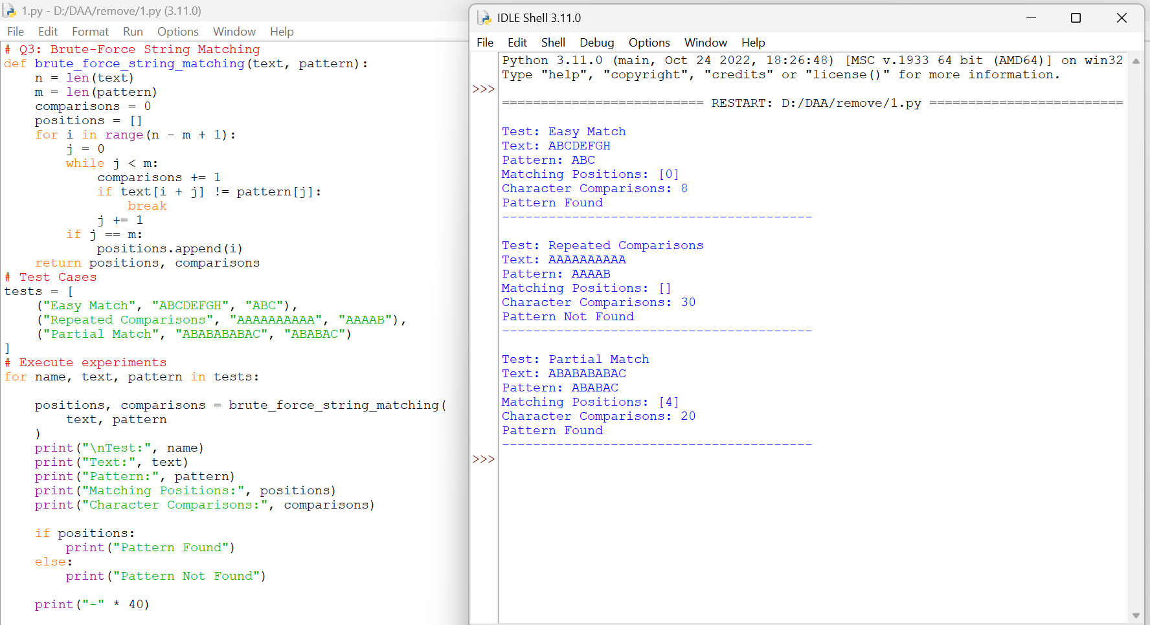
6. Experimental Analysis
Test 1 – Easy Match
The pattern ABC matches at the beginning of the text. The remaining positions are checked, but most comparisons fail immediately. Therefore, only 8 comparisons are required.
Test 2 – Repeated Comparisons
The text contains repeated characters A. The first four characters of the pattern match, but the fifth character does not. This happens at all six possible alignments, resulting in 30 comparisons.
Test 3 – Partial Match
The text and pattern share several common characters. The algorithm repeatedly matches a partial pattern before encountering a mismatch. It finally finds the pattern at index 4, requiring 20 comparisons.
7. Why Does One Input Require More Work?
The number of comparisons depends not only on the length of the text and pattern but also on their character arrangement.
- Repeated characters can cause the same partial comparisons to happen multiple times.
- A mismatch at the first character reduces the number of comparisons.
- A mismatch near the end of the pattern increases the number of comparisons.
- Similar prefixes between the text and pattern can cause repeated work.
Therefore, two inputs having similar lengths may require different computational effort.
8. Time Complexity Analysis
Let:
- n = Length of text
- m = Length of pattern
Case | Time Complexity
Best Case | O(m)
Average Case | O(n) approximately, for typical dissimilar characters
Worst Case | O(n × m)
Space Complexity: O(1) auxiliary space, excluding the list used to store matching positions.
10. Conclusion
Thus, Brute-Force String Matching was implemented and tested using three different text-pattern combinations. The experiment demonstrated that repeated characters and partial pattern matches increase the number of character comparisons. The algorithm's performance depends on both input size and the arrangement of characters.

Q4 – Closest Pair and the Cost of Examining Every Possibility
Problem Context: Drone Collision-Risk Monitoring
1. Aim
To implement the Brute-Force Closest Pair algorithm to identify the two closest drones based on their 2D coordinates and analyse the number of distance calculations for different input sizes.
2. Concept
The Closest Pair problem finds two points that have the minimum Euclidean distance between them.
Each drone is represented by coordinates:
$$D_{i}=\left(x_{i},y_{i}\right)$$
The distance between two points is calculated using:
$$d=\sqrt{{\left(x_{2}-x_{1}\right)}^{2}+{\left(y_{2}-y_{1}\right)}^{2}}$$
The Brute-Force approach compares every unique pair of points and finds the pair having the minimum distance.
3. Algorithm
- Read the coordinates of all drones.
- Initialize the minimum distance as infinity.
- Select the first drone.
- Compare it with every drone after it.
- Calculate the Euclidean distance between each pair.
- If the calculated distance is smaller than the current minimum, update the minimum distance and closest pair.
- Repeat until all unique pairs are examined.
- Display the closest pair and minimum distance.
4. Mathematical Derivation
For n drones, every drone must be compared with all other drones, without repeating pairs.
The number of unique pairs is:
\[ C(n,2)=\frac{n(n-1)}{2} \]
For example:
Number of drones (n) | Unique pairs
5 | 10
10 | 45
20 | 190
50 | 1225
100 | 4950
Therefore, the number of distance calculations increases quadratically as the number of drones increases.
5. Python Implementation
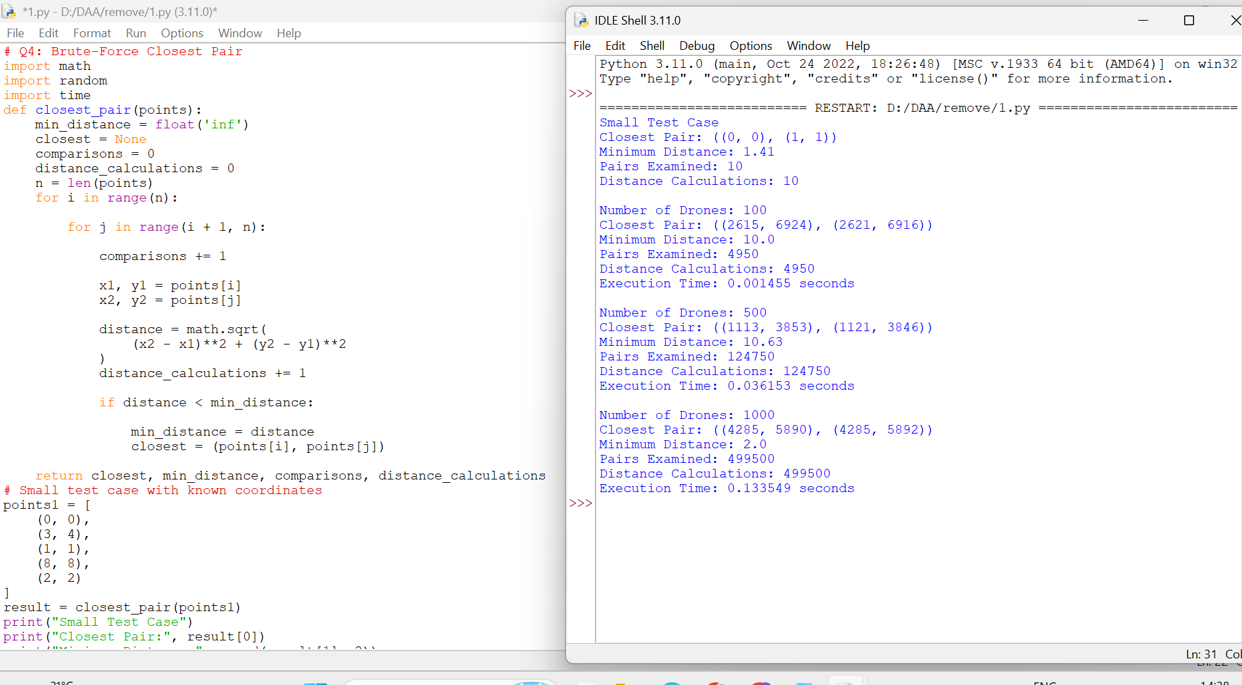
6. Experimental Analysis
The experiment demonstrates that:
- For 100 drones, 4,950 unique pairs are examined.
- For 500 drones, 124,750 pairs are examined.
- For 1,000 drones, 499,500 pairs are examined.
As the number of drones increases, the number of comparisons and distance calculations increases rapidly.
The algorithm avoids duplicate comparisons by using the inner loop from i + 1 instead of starting again from zero.
8. Scalability Analysis
The theoretical time complexity is:
$$T\left(n\right)=O\left(n^{2}\right)$$
The space complexity is:
$$S\left(n\right)=O\left(1\right)$$
excluding the input points and the returned pair.
Acceptable response time: For this experiment, we define a response time of one second or less as acceptable for a single closest-pair calculation.
To identify the practical limit, we should increase the input size gradually and measure the execution time on the same computer.
The brute-force approach becomes impractical when the number of drones is so large that examining every pair exceeds the one-second response-time requirement.
9. Computational Inefficiency
The main limitation is that the algorithm examines every possible pair, even when many pairs are clearly far apart.
A redesigned strategy should reduce unnecessary distance calculations by using the spatial arrangement of points.
For example, a divide-and-conquer approach can divide the points into smaller regions and examine only relevant candidate pairs near the dividing boundary.
This can reduce the time complexity to:
$$O\left(n\log{n}\right)$$
10. Conclusion
Thus, the Brute-Force Closest Pair algorithm was implemented and tested using different numbers of drone coordinates. The experiment demonstrated that the number of unique pairs is $\frac{n\left(n-1\right)}{2}.$Although the method is simple and guarantees the closest pair, its quadratic growth makes it less suitable for large-scale drone monitoring systems.

Q5 – Derive a Convex Hull Algorithm from a Geometric Principle
Problem Context: Wildlife Reserve Boundary Monitoring
1. Aim
To develop and implement a Brute-Force Convex Hull algorithm using the geometric principle that all remaining points must lie on the same side of a candidate boundary line.
2. Concept
A Convex Hull is the smallest convex polygon that contains all the given points.
In this problem, monitoring stations are represented using 2D coordinates.
$$P_{i}=\left(x_{i},y_{i}\right)$$
The objective is to identify the outer boundary points and connect them to form a convex polygon.
Geometric principle:
A line joining two candidate points forms a possible convex hull edge if all other points lie on the same side of that line.
3. Geometric Decision Rule
Consider two points:
$$P_{1}=\left(x_{1},y_{1}\right), P_{2}=\left(x_{2},y_{2}\right)$$
For another point $P_{3}=\left(x_{3},y_{3}\right)$ calculate the cross product:
$$C=\left(x_{2}-x_{1}\right)\left(y_{3}-y_{1}\right)-\left(y_{2}-y_{1}\right)\left(x_{3}-x_{1}\right)$$
The result determines the position of the third point:
- If C is positive, the point lies on the left side.
- If C is negative, the point lies on the right side.
- If C is zero, the points are collinear.
If all remaining points lie on the same side of the candidate line, it can be accepted as a convex hull edge.
4. Algorithm
- Read the coordinates of all monitoring stations.
- Select two points to form a candidate line.
- Calculate the cross product for every other point.
- Check whether all points lie on the same side.
- If they lie on the same side, accept the candidate edge.
- Repeat for every possible pair of points.
- Collect the boundary points.
- Arrange the boundary points in angular order around their centroid.
- Display the convex hull.
5. Python Implementation
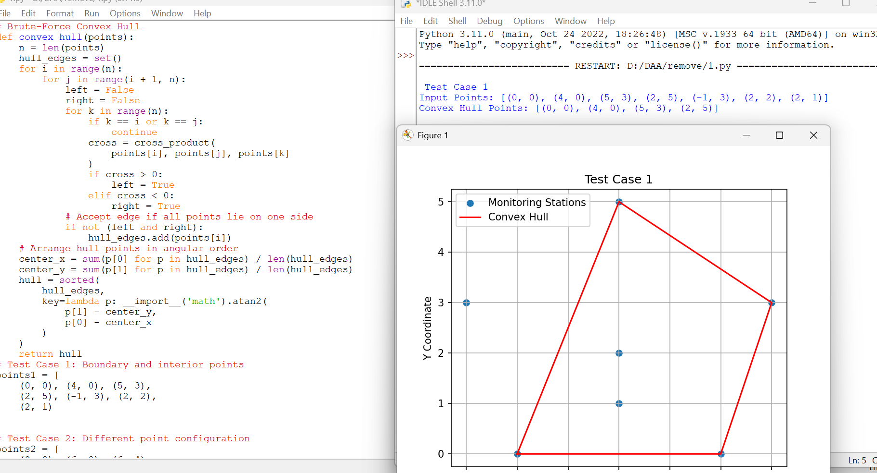
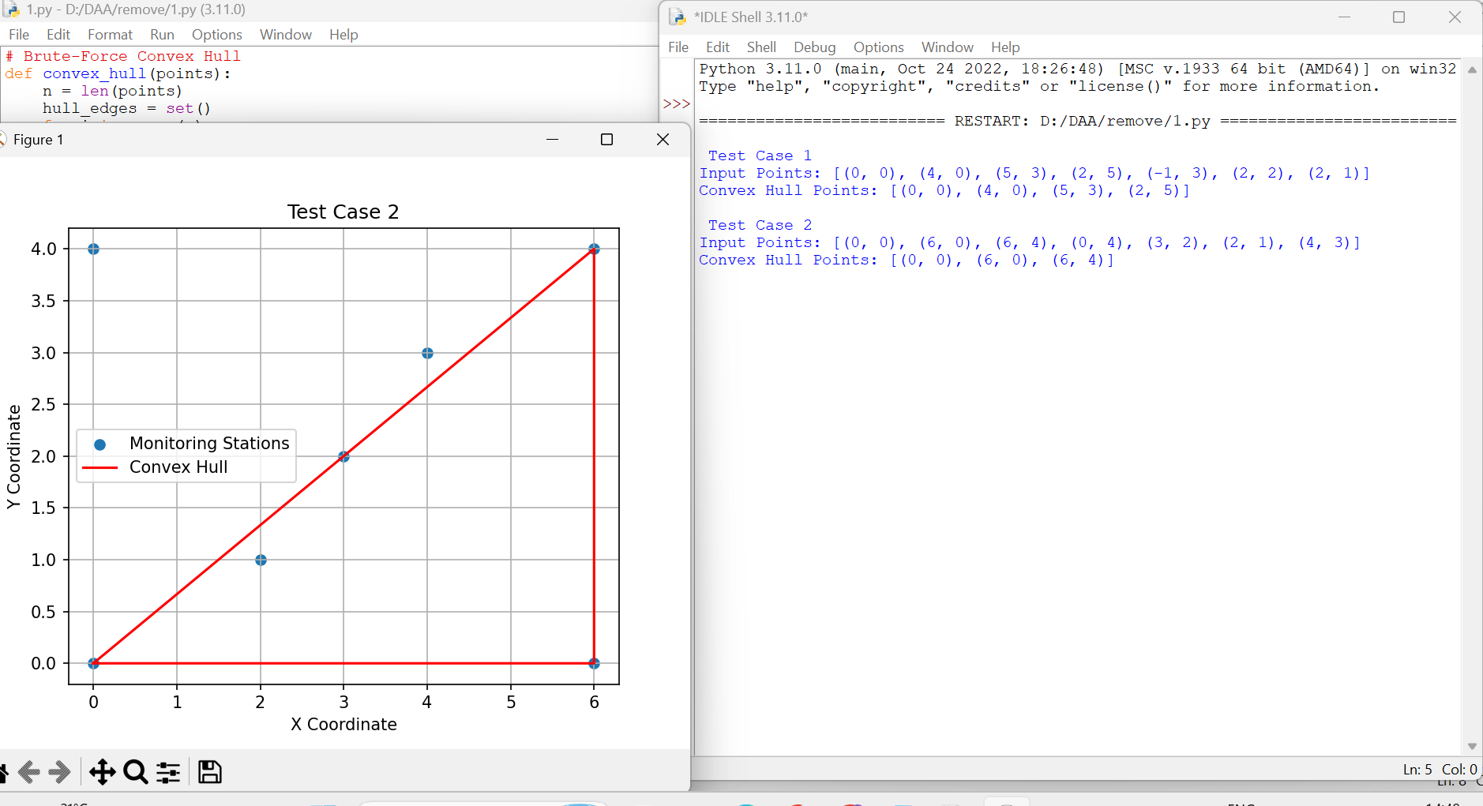
7. Pseudocode
BEGIN
Read all points
FOR every pair of points P[i], P[j]
Set left = false
Set right = false
FOR every other point P[k]
Calculate cross product
IF cross product > 0
left = true
ELSE IF cross product < 0
right = true
END FOR
IF NOT (left AND right)
Accept P[i], P[j] as a hull edge
END FOR
Collect boundary points
Arrange boundary points in angular order
Display convex hull
END
8. Computational Analysis
The algorithm examines every possible pair of points.
- Selecting two candidate points requires O(n²) operations.
- Checking all remaining points for each pair requires O(n) operations.
Therefore, the overall time complexity is:
$$T\left(n\right)=O\left(n^{2}\right)×O\left(n\right)$$
$$\boxed{T\left(n\right)=O\left(n^{3}\right)}$$
The algorithm requires additional memory to store the boundary points and edges.
9. Correctness Explanation
The geometric test is based on the cross product of three points.
If all remaining points lie on the same side of a line joining two candidate points, that line acts as a supporting line for the point set.
Therefore, the candidate segment belongs to the outer convex boundary, provided the endpoints are distinct and the point set is not entirely collinear.
By examining every pair of points, the algorithm identifies the supporting boundary edges.
10. Conclusion
Thus, the Brute-Force Convex Hull algorithm was designed and implemented using the cross-product geometric principle. Two different point configurations were tested and visualized. The algorithm identifies the outer boundary by checking whether all remaining points lie on the same side of a candidate line. Its time complexity is O(n³), making it suitable for small datasets but less efficient for large numbers of monitoring stations.

Q6 – Exhaustive Search and Combinatorial Growth
Problem Context: Humanitarian Airlift Planning
1. Aim
To implement an Exhaustive Search algorithm to select packages that maximize humanitarian value without exceeding the helicopter's maximum payload capacity.
2. Concept
Exhaustive Search is a problem-solving technique that examines all possible combinations of available items to find the optimal solution.
In this problem, each package contains:
- Package ID
- Weight
- Humanitarian Value
The objective is to select a combination of packages that:
- Does not exceed the maximum payload capacity.
- Provides the maximum total humanitarian value.
3. Algorithm
- Read the package details and payload capacity.
- Generate all possible package combinations.
- Calculate the total weight of each combination.
- Check whether the total weight is within the payload limit.
- Calculate the total humanitarian value of feasible combinations.
- Compare the values with the current maximum value.
- Store the combination having the maximum value.
- Display the selected packages, total weight and maximum value.
4. Mathematical Analysis
For n available packages, each package has two possibilities:
- Selected (1)
- Not selected (0)
Therefore, the total number of possible combinations is: [ 2^n ]
The growth of combinations is shown below.
Packages (n) | Combinations (2ⁿ)
5 | 32
10 | 1,024
15 | 32,768
20 | 1,048,576
25 | 33,554,432
As the number of packages increases, the number of combinations grows exponentially.
5. Python Implementation
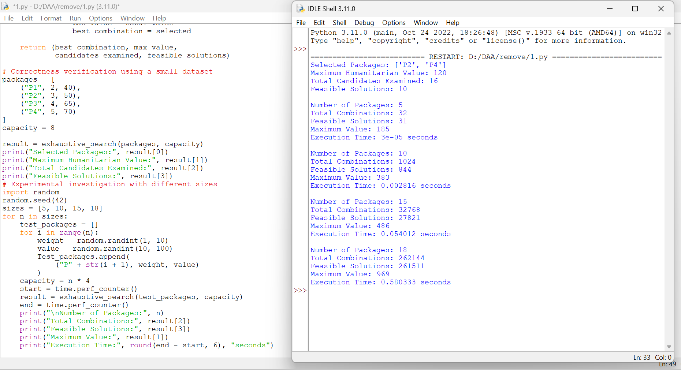
6. Correctness Verification
Consider four packages with a maximum payload capacity of 8.
Package | Weight | Humanitarian Value
P1 | 2 | 40
P2 | 3 | 50
P3 | 4 | 65
P4 | 5 | 70
The best combination is:
- P2: Weight = 3, Value = 50
- P4: Weight = 5, Value = 70
Total weight: [ 3+5=8 ]
Total humanitarian value: [ 50+70=120 ]
The combination satisfies the payload limit and provides the maximum value.
Therefore, the algorithm identifies the correct optimal solution for this small test instance.
7. Experimental Analysis
We use four different problem sizes:
- 5 packages
- 10 packages
- 15 packages
- 18 packages
The number of candidate combinations is calculated using: [ 2^n ]
Packages | Candidate combinations
5 | 32
10 | 1,024
15 | 32,768
18 | 262,144
The program measures the execution time and counts the feasible solutions for each experiment.
8. Why Does Computational Effort Increase Dramatically?
Exhaustive Search generates every possible combination of packages.
When one additional package is introduced, every existing combination creates two possibilities:
- The new package is selected.
- The new package is not selected.
Therefore, the number of combinations doubles whenever one package is added.
Increasing the number of packages from 10 to 20 increases the search space by 1024 times.
This is why Exhaustive Search becomes expensive for larger datasets.
9. Time Complexity Analysis
For n packages:
- Number of combinations = (2^n)
- Each combination checks up to n packages.
10. Deployment Decision
Assume the helicopter planning system must generate a loading decision within 1 second.
I would use the following deployment procedure:
- Run the experiments for 5, 10, 15 and 18 packages.
- Record the execution time on the same computer.
- Identify the largest tested input size that completes within one second.
- Use that size as the provisional deployment limit.
Exhaustive Search is suitable for small package collections because it guarantees an optimal solution. For larger collections, a redesigned approach such as dynamic programming can reduce the computational effort.
11. Conclusion
Thus, the Exhaustive Search algorithm was implemented to select the best combination of humanitarian packages within a fixed payload capacity. The experiment demonstrates that the number of possible combinations grows exponentially as the number of packages increases. Although it guarantees an optimal solution, its computational cost makes it unsuitable for large-scale package selection.

Q7 – Diagnose, Redesign and Validate
Day-4 Design Challenge
Selected Problem: Brute-Force Closest Pair – Drone Collision-Risk Monitoring
1. Introduction
In Q4, we implemented the Brute-Force Closest Pair algorithm to identify the two nearest drones using their coordinates.
The original algorithm examines every possible pair of drones to calculate the distance.
Although it produces the correct result, the number of distance calculations increases rapidly when the number of drones increases.
Therefore, this question redesigns the original approach to reduce unnecessary distance calculations.
A. Diagnose the Computational Bottleneck
1. Original Algorithm
The Brute-Force Closest Pair algorithm compares every unique pair of points.
The number of pairs is: [ C(n,2)=frac{n(n-1)}{2} ]
2. Computational Bottleneck
The main computational problem is that the algorithm calculates the distance between every possible pair of drones.
As the number of drones increases, the number of distance calculations increases quadratically.
Number of drones | Distance calculations
100 | 4,950
500 | 124,750
1,000 | 499,500
2,000 | 1,999,000
3. Identified Problems
- Every possible pair is examined.
- Many unnecessary distance calculations are performed.
- Computational effort increases with the square of the input size.
- The algorithm does not use the spatial arrangement of drones to reduce comparisons.
Diagnosis: The main bottleneck is repeated examination of all possible drone pairs, resulting in O(n²) time complexity.
B. Define the Design Objective
The main objective of the redesigned algorithm is to reduce unnecessary distance calculations while still identifying the closest pair correctly.
The design objectives are:
- Reduce the number of distance calculations.
- Avoid comparing points that are clearly far apart.
- Use the spatial arrangement of the drones.
- Maintain the correctness of the closest-pair result.
- Improve performance for larger datasets.
Measurable objective: Reduce the number of distance calculations compared with the original brute-force implementation while obtaining the same minimum distance.
C. Design the Revised Computational Strategy
1. Proposed Strategy – Divide and Conquer
Instead of comparing every pair directly, divide the points into smaller groups based on their X-coordinate.
The revised approach follows these steps:
- Sort all points based on their X-coordinate.
- Divide the points into two halves.
- Find the closest pair in the left half.
- Find the closest pair in the right half.
- Select the smaller of the two distances.
- Examine points near the dividing line that may form a closer pair across the two halves.
- Return the minimum distance and corresponding pair.
2. What Has Changed?
Original approach | Redesigned approach
Checks every pair | Divides points into smaller groups
O(n²) time | O(n log n) time
No preprocessing | Sorts points initially
Repeated distance calculations | Reduces unnecessary comparisons
Simple implementation | More complex implementation
3. Advantages
- Reduces unnecessary comparisons.
- Uses the spatial arrangement of points.
- Improves scalability.
- Suitable for larger drone monitoring datasets.
4. Trade-offs
- Requires sorting before processing.
- Uses additional memory for recursive processing.
- Implementation is more complex than brute force.
- Small datasets may still be handled more simply using brute force.
5. Pseudocode
BEGIN
Sort all points by X-coordinate
FUNCTION ClosestPair(points)
IF number of points <= 3
Find closest pair using brute force
RETURN minimum distance and pair
Divide points into left and right halves
Find closest pair in left half
Find closest pair in right half
Select the smaller distance
Create a strip of points near the dividing line
Compare nearby points in the strip
Update minimum distance if a closer pair is found
RETURN closest pair and minimum distance
END FUNCTION
Display closest pair and distance
END
D. Predict Before Implementing
Before implementation, the following behaviour is predicted:
- The redesigned algorithm will perform fewer distance calculations for larger datasets.
- The original algorithm will examine all possible pairs.
- The redesigned algorithm will divide the dataset into smaller groups.
- The number of unnecessary comparisons will decrease.
- The performance improvement will become more noticeable as the number of drones increases.
Expected improvement measure: Number of distance calculations and execution time.
E. Implement and Validate the Redesign
1. Python Implementation
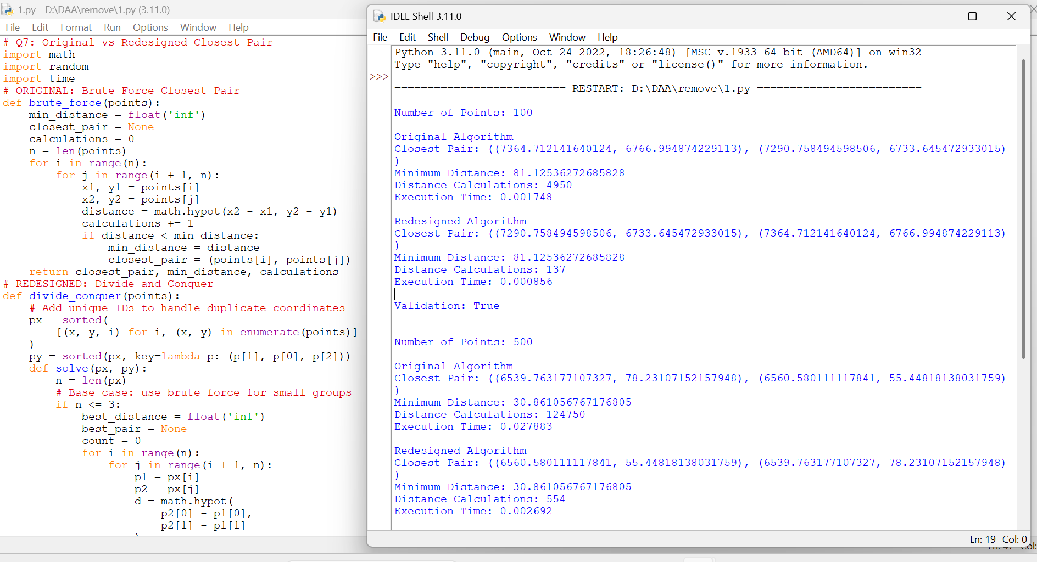
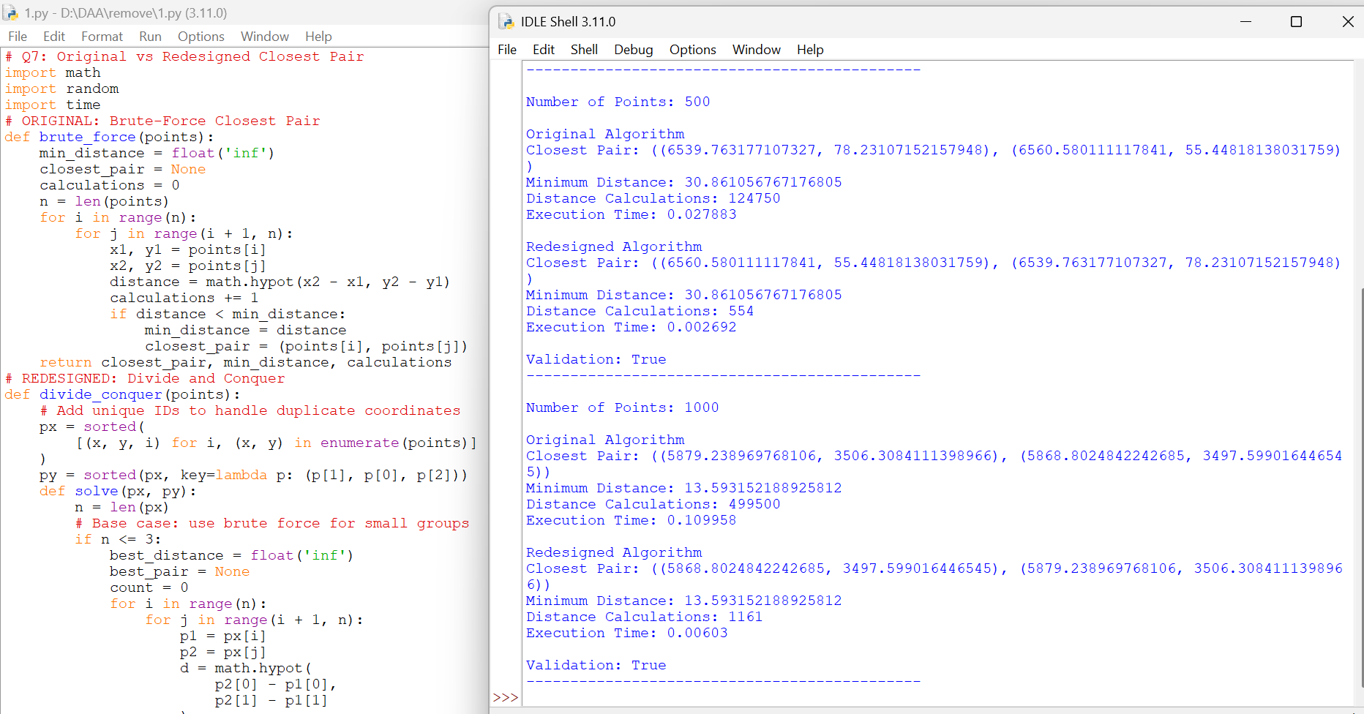
3. Validation
The following conditions are used to validate the redesigned algorithm:
- Both algorithms must identify the same minimum distance.
- Both must return a valid closest pair.
- The redesigned algorithm should reduce distance calculations for larger datasets.
- Execution times should be measured using the same computer and test data.
The Validation statement in the program checks whether both algorithms produce the same minimum distance.
F. Defend the Final Design
1. Evaluation of the Redesign
The redesigned algorithm uses Divide and Conquer to reduce unnecessary distance calculations.
The following improvements are expected:
- The original algorithm examines every possible pair.
- The redesigned algorithm divides the points into smaller groups.
- The redesigned algorithm examines only nearby points around the dividing boundary.
- Both algorithms should produce the same minimum distance.
2. Complexity Comparison
Feature | Brute Force | Divide and Conquer
Best/overall time bound | O(n²) | O(n log n)
Distance calculations | More | Fewer for large inputs
Sorting required | No | Yes
Additional memory | O(1) auxiliary | O(n)
Implementation | Simple | Complex
3. Limitations and Trade-offs
- Divide and Conquer requires initial sorting.
- It needs additional memory.
- Its implementation is more complex.
- For very small datasets, Brute Force may be easier and sufficiently fast.
- The redesigned approach is more suitable for larger datasets.
4. Final Engineering Decision
The redesigned Divide and Conquer approach is recommended for large-scale drone collision monitoring because it reduces unnecessary distance calculations and improves scalability.
However, the original Brute-Force approach remains suitable for small datasets because it is simple and easy to implement.
2. Conclusion
Thus, the Brute-Force Closest Pair algorithm was analysed and redesigned using the Divide and Conquer strategy. The original algorithm has O(n²) time complexity, whereas the redesigned algorithm achieves O(n log n) time complexity. Both approaches are validated by comparing their minimum distances using the same input datasets.
The redesign provides a more scalable solution for large drone monitoring systems, although it requires additional memory and a more complex implementation.

